ASSIGNMENT-4

|  |  |
| --- | --- |
| **Assignment Date** | 03 November 2022 |
| **Team ID** | PNT2022TMID32880 |
| **Maximum Marks** | 2 Marks |

**Question 1:**

Pull an Image from docker hub and run it in docker playground.

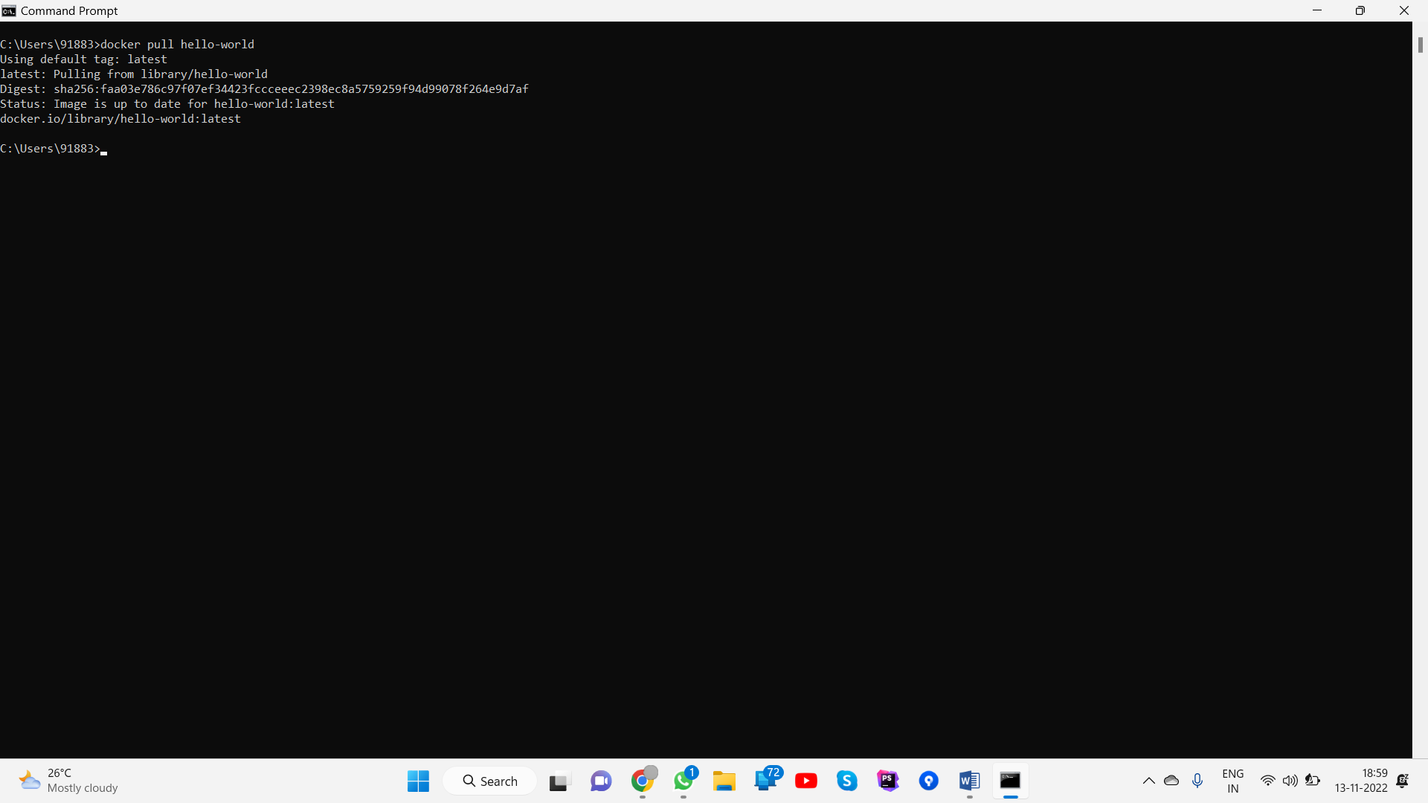

**Question 2:**

Create a docker file for the jobportal application and deploy it in Docker desktop application.

FROM helloworld:latest WORKDIR ~/Desktop/ ADD . helloworld/

WORKDIR ~/Desktop/htmlfile RUN pip install -r requirements RUN chmod +x app.sh

CMD ["/bin/sh","app.sh"]

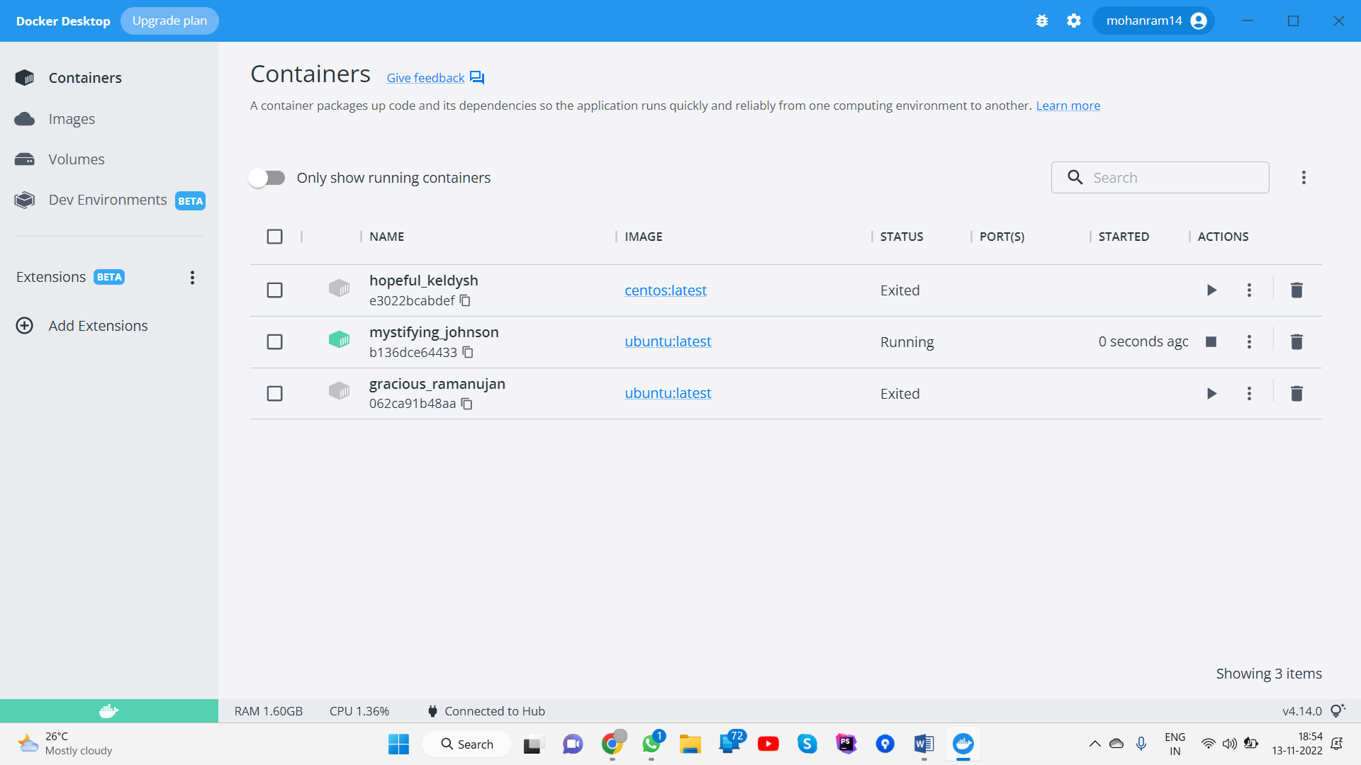

**Question 3:**

Create a IBM container registry and deploy helloworld app or jobportalapp.

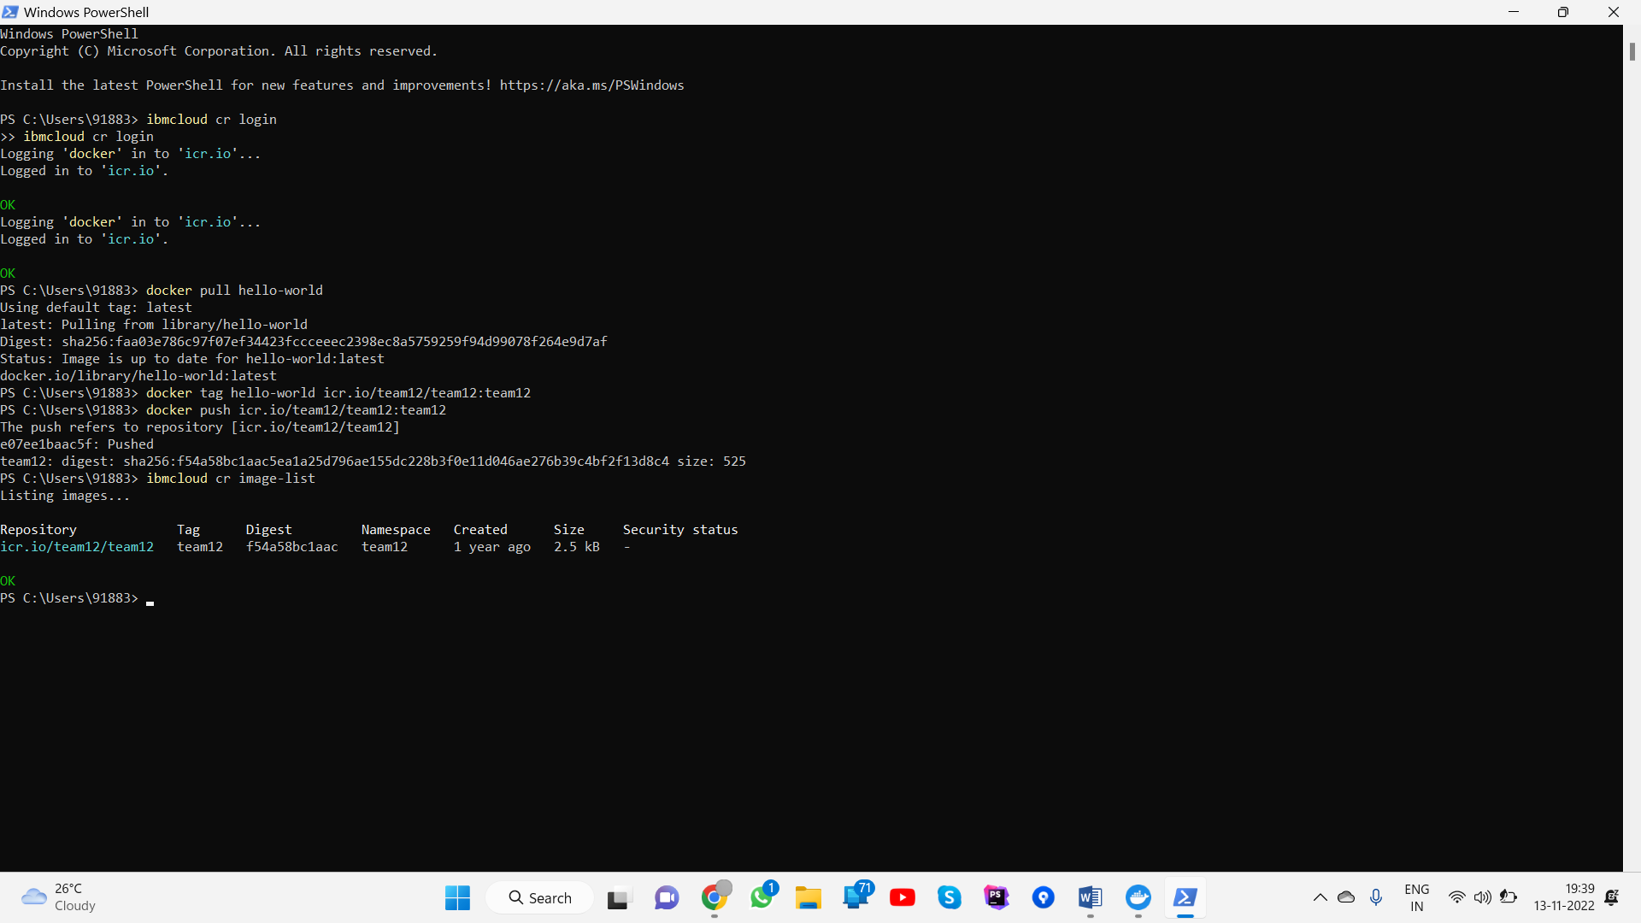

**Question 4:**

Create a Kubernetes cluster in IBM cloud and deploy helloworld image or jobportal image and also expose the same app to run in nodeport.

